Decision Support System for Electric Vehicles Selection Using Simple Additive Weighting

**Thomas Ch. Suwanto 1, Steven D. F. Koloay 2, Angelia M. Adrian 3**

1 Informatics Engineering Study Program; Faculty of Engineering,

Universitas Katolik De La Salle Manado, Kombos Kairagi Satu, Indonesia

|  |  |  |
| --- | --- | --- |
| **Article Info** |  | **ABSTRACT** |
| ***Article history:***  Received Month xx, 20xx  Revised Month xx, 20xx  Accepted Month xx, 20xx |  | Electric vehicles (EVs) are vehicles entirely powered by electric motors using energy stored in batteries. In Indonesia, interest in electric vehicles is increasing, supported by government initiatives to reduce carbon emissions and improve infrastructure. The main issues faced are potential buyers' hesitation in choosing electric vehicles due to the limited variety of models, high prices, and insufficient information provided to buyers.  This research aims to build a decision support system for selecting electric vehicles using the Simple Additive Weighting (SAW) method. The selection of electric vehicles using the SAW method requires criteria derived from sales brochures, official dealer websites, automotive exhibitions, and trusted news sources. The criteria used include price, range, battery capacity, passenger capacity, and vehicle speed. In the application development process, the waterfall method was used. The modeling tools used in this research are Flowcharts, Data Flow Diagrams, and Entity Relationship Diagrams, while the application development uses HTML and JavaScript.  Based on the research conducted, all features function well, and out of the five alternatives used in this study, the results show that the Hyundai Ioniq 6 has a score of 0.9, while the Wuling Air EV Long Range has a score of 0.59. |
| ***Keywords:***  Decision Support System  Electric Vehicles  Simple Additive Weighting  Vehicles Selection |
| *This is an open access article under the* [*CC BY-SA*](https://creativecommons.org/licenses/by-sa/4.0/) *license.* |
| ***Corresponding Author:***  Thomas Ch. Suwanto,  Informatics Engineering Study Program; Faculty of Engineering, Universitas Katolik De La Salle Manado Kombos Kairagi Satu, 95253, Indonesia  Email: tsuwanto@unikadelasalle.ac.id | | |

1. **INTRODUCTION**

Electric vehicles (EVs) are vehicles entirely powered by electric motors, using energy stored in batteries. Electric vehicles first appeared in the late 19th century, but their popularity declined in the early 20th century with the dominance of gasoline-powered vehicles. In recent decades, electric vehicles have regained significant attention as a more environmentally friendly alternative to conventional vehicles. This is driven by concerns about climate change, air pollution, and dependence on fossil fuels.

With technological advancements and infrastructure improvements, electric vehicles are expected to play a crucial role in the future of transportation. The development of autonomous vehicles is also often combined with electric vehicles to create more efficient and safer transportation solutions. Many electric vehicle companies offer models with different features and specifications. Examples of electric vehicles already sold in Indonesia include the Hyundai Ioniq 6, Hyundai Ioniq 5 Standard, Wuling Air-EV, Lexus UX 300e, Toyota BZ4X, and others. Interest in electric vehicles in Indonesia is growing, supported by government efforts to reduce high carbon emissions, improve infrastructure, and increase market acceptance. According to the Ministry of Public Works and Housing [1], the number of electric vehicles sold in Indonesia as of April 2024 reached 133,225 units.

However, despite the growing interest in EVs, potential buyers in Indonesia face challenges in selecting the most suitable electric vehicle due to the variety of models, differing specifications, and complex criteria such as price, battery range, charging infrastructure compatibility, and environmental impact. This complexity often leads to decision-making difficulties, as consumers lack a structured method to evaluate and compare available options effectively.

The Simple Additive Weighting (SAW) method is used in the decision-making process to provide accurate evaluations based on the values and weights of predetermined criteria. This is very useful in solving the problem of electric vehicle selection. Fishburn and MacCrimmon stated that the SAW method is often referred to as the weighted sum method. The basic concept of the SAW method is to find the total weighted performance score for each alternative across all attributes [2]. The electric vehicle with the highest score is considered the best based on the specified criteria. Related research using the SAW method includes studies on car rental selection in Yogyakarta [3], Toyota vehicle selection at Tunas Toyota Cilegon [4], SUV selection recommendations [5], determining the most popular Honda car models [6], new car selection at AUTO2000 [7], rental car recommendations using the Main Rent Car application [8], credit eligibility assessment at PT. Leasing Arthaprima Finance Kotamobagu [9], selecting the best mechanic at PT Arista Auto Lestari [10], used motorcycle purchases at PT. Zakiyah Motor Bengkulu [11], and used motorcycle selection at CV. Bandar Sri Rezeki [12].

A Decision Support System (DSS) integrated with the SAW method is crucial in EV selection because it provides a systematic and objective framework for evaluating multiple alternatives based on user-defined criteria. The importance of a DSS lies in its ability to simplify complex decision-making processes, reduce bias, and ensure that decisions align with the user’s preferences and priorities. For EV selection, a DSS helps users navigate the diverse options by quantifying trade-offs between criteria such as cost, performance, and sustainability, ultimately leading to more informed and efficient decisions.

In this context, this research will focus on the development and implementation of a Decision Support System (DSS). The DSS is designed to help users input their preferences based on the available criteria. The system will then generate scores for electric vehicles based on SAW calculations. The primary objective of this research is to develop a DSS that facilitates the selection of electric vehicles by providing a reliable and user-friendly tool for evaluating alternatives based on predefined criteria.

1. **LITERATURE REVIEW**
2. Electric Vehicle

Electric vehicles are vehicles that use direct current electric motors and rely on energy stored in batteries or energy tanks. Generally, electric vehicles have several advantages over conventional fuel-powered vehicles, including reducing greenhouse gas emissions as they do not require fossil fuels as their primary energy source [13].

According to Presidential Regulation No. 79 of 2023 concerning Amendments to Presidential Regulation No. 55 of 2019 on the Acceleration of the Battery-Based Electric Motor Vehicle Program for Road Transportation [14], electric vehicles are electromechanical devices that use electric power to generate mechanical energy for propulsion. The electric power source used to supply power to the electric motor is a battery or other electrical energy storage medium, which is then referred to as a battery.

1. Decision Support System

Decision Support Systems (DSS) are interactive computer-based systems designed to assist decision-makers in solving problems and making informed choices, particularly in complex and semi-structured decision environments. DSS supports the decision-making process through key steps: identifying problems by analyzing data to uncover issues, gathering relevant data from multiple sources, determining decision-making approaches such as weighted scoring, and evaluating available options by comparing alternatives based on predefined criteria[15].

The concept of Decision Support Systems (DSS) was first introduced by Michael S. Scott Morton in the early 1970s as a system for managerial decision-making. This system is a computer-based system designed to assist decision-makers by utilizing data and predetermined models to solve various unstructured problems [16].

1. Simple Additive Weighting Method

The Simple Additive Weighting (SAW) method is one of the methods in *Decision Support Systems* (DSS) known as the weighted sum method. This method is called such because the SAW method essentially calculates the weighted sum of all attributes for each alternative. The basic concept of the SAW method is to find the total weighted performance score for each alternative based on all available attributes. The SAW method requires a normalization process of the decision matrix (*X*) to a scale that allows comparison between alternatives. The following is the calculation process in *Simple Additive Weighting* [17]:

1. Preparing the decision matrix involves combining alternative values and criteria using the appropriate matrix equation [17]:

$Xij= \left[\begin{matrix}X11 & Xnm \\ Xnm & Xnm\end{matrix}\right]$... (1)

Explanation :

Xij = Decision Matrix

i = Alternative (row)

j = Attribute and Criterion (Column)

n = Number of attributes

m = Number of Alternatives

1. The process of calculating the normalization matrix involves adjusting the value of each attribute to a scale of 0 to 1, taking into account the type of criteria used, using the corresponding equation [17].

$Rij= \frac{Xij}{max Xj Xij} If J is Benefit$ (2)

$Rij= \frac{min Xj Xij}{Xij} If J is Cost$ (3)

Explanation :

Rij = Normalized matrix

Max Xij = The Highest Value in column j

Min Xij = The Lowest Value in column j

Xij = Decision Matrix

1. The process of calculating preference values involves multiplying all attributes by the criterion weights for each alternative, using the specified equation [17]:
$$V1= \sum_{j=1}^{n}{Wj Rij} (4)$$

2. **METHOD**

This research adopts the Waterfall software development method, which consists of:

1. Analysis  
   This phase begins with understanding the needs and objectives of developing the software. The development team studies the needs and user requirements while determining the features and functions required.
2. Design  
   In this phase, the architecture, design, and specifications of the software are established. The design also includes creating flow diagrams and designing the user interface.
3. Coding  
   Coding refers to the creation and testing of program code to ensure the quality of the software being developed.
4. Testing  
   After the program code is completed, the testing phase is conducted to ensure the software functions correctly. The result is software that meets the user's needs.
5. Support  
   The maintenance process only occurs after the developer delivers the product to the consumer. The development team continuously improves, updates, and maintains the software in accordance with user needs. This step not only keeps the software in good condition but also allows for periodic updates.
6. **RESULTS AND DISCUSSION**

**4.1. SAW Calculation**

In the calculation of the Simple Additive Weighting method, criteria are required to be used in selecting an electric car. The following are the criteria used in the development of the application, as shown in Table 1.

**Tabel 1. List of Criterias**

|  |  |  |
| --- | --- | --- |
| **Code** | **Criterion** | **Classification** |
| C1 | Price | Cost |
| C2 | Max Distance | Benefit |
| C3 | Battery Capacity | Benefit |
| C4 | Number of Passengers | Benefit |
| C5 | Speed | Benefit |

After determining the criteria to be used, the next step is to establish subcriteria or indicators for each criterion. The indicators for each criterion are as follows: for C1, which is a cost criterion, a value of 5 represents the least expensive, descending to a value of 1, which is the most expensive; for C2, C3, and C5, which are benefit criteria, a value of 2 represents the smallest value, ascending to a value of 5, which is the largest; for C4, also a benefit criterion, a value of 4 represents a smaller value, while a value of 5 represents a larger value. The indicators for each criterion are presented in Table 2 below.

**Tabel 2. Determination of Criterion Indicators**

|  |  |  |  |
| --- | --- | --- | --- |
| **Criterion** | **Criterion Name** | **Indicators** | **Value** |
| C1 | Price | Rp 300.000.000 – Rp 599.999.999 | 5 |
| Rp 600.000.000 – Rp 899.999.999 | 4 |
| Rp 900.000.000 – Rp 1.199.999.999 | 3 |
| Rp 1.200.000.000 – Rp 1.499.999.999 | 2 |
| Rp 1.500.000.000 > | 1 |
| C2 | Max Distance | 200 km – 299 km | 2 |
| 300 km – 399 km | 3 |
| 400 – 499 km | 4 |
| 500> | 5 |
| C3 | Baterry Capacity | 20 kWh – 39 kWh | 2 |
| 40 kWh – 59 kWh | 3 |
| 60kWh – 79 kWh | 4 |
| 80 kWh – 100 kWh | 5 |
| C4 | Number of Passengers | 4 Passengers | 4 |
| 5 Passangers | 5 |
| C5 | Speed | 100 kph | 2 |
| 160 kph | 3 |
| 185 kph | 4 |

After determining the criteria and their respective indicators, the next step is to assign weights to each criterion. The following is the weighting of each criterion, which can be seen in Table 3. These weights are used as preference weights.

**Tabel 3. Weighting of Criterion**

|  |  |  |
| --- | --- | --- |
| **Criterion** | **Weight** | |
| C1 | 30 | 0.3 |
| C2 | 20 | 0.2 |
| C3 | 20 | 0.2 |
| C4 | 10 | 0.1 |
| C5 | 20 | 0.2 |
| **Total** | **100** | **1** |

In this calculation, five types of electric cars are used as examples of alternatives to be selected. These three alternative examples are presented below. The details of the criteria for these alternatives can be seen in Table 4 and the conversion in Table 5.  
A1 = Hyundai Ioniq 6  
A2 = Hyundai Ioniq 5 Standard  
A3 = Wuling Air-EV Long Range  
A4 = Lexus UX 300e  
A5 = Toyota BZ4X

**Tabel 4. Example of Alternatives**

|  |  |  |  |  |  |
| --- | --- | --- | --- | --- | --- |
| **Aternative** | **Criterion** | | | | |
| **C1** | **C2** | **C3** | **C4** | **C5** |
| **A1** | Rp. 1.197.000.000 | 519 km | 77,4 kWh | 5 Passengers | 185 kph |
| **A2** | Rp. 681.900.000 | 384 km | 58 kWh | 5 Passengers | 185 kph |
| **A3** | Rp316.000.000 | 300 km | 26.7 kWh | 4 Passengers | 100 kph |
| **A4** | Rp1.464.000.000 | 300 km | 54.35 kWh | 5 Passengers | 160 kph |
| **A5** | Rp1.190.000.000 | 500 km | 71.4 kWh | 5 Passengers | 160 kph |

**Tabel 4. Criterion Conversion**

|  |  |  |  |  |  |
| --- | --- | --- | --- | --- | --- |
| **Alternative** | **Criterion** | | | | |
| **C1** | **C2** | **C3** | **C4** | **C5** |
| **A1** | 3 | 5 | 4 | 5 | 5 |
| **A2** | 4 | 3 | 3 | 5 | 5 |
| **A3** | 5 | 3 | 2 | 4 | 3 |
| **A4** | 2 | 3 | 3 | 5 | 2 |
| **A5** | 3 | 5 | 4 | 5 | 2 |

From table 5 that has been created, a matrix is generated, which can be seen as follows:

$$X=\left[\begin{aligned}3 5 4 5 5 \\ 4 3 3 5 5 \\ 5 3 2 4 3 \\ 2 3 3 5 2 \\ 3 5 4 5 2\end{aligned}\right]$$

In the next step, matrix normalization is performed, and each criterion is calculated. The following are the results of the normalization values:

|  |
| --- |
| $$r11= \frac{min⁡(3,4,5,2,3)}{3}= \frac{2}{3}=0,67$$ |
| $$r12= \frac{min⁡(3,4,5,2,3)}{4}= \frac{2}{4}=0,5$$ |
| $$r13= \frac{min⁡(3,4,5,2,3)}{5}= \frac{2}{5}=0,4$$ |
| $$r14= \frac{min⁡(3,4,5,2,3)}{2}= \frac{2}{2}=1$$ |
| $$r15= \frac{min⁡(3,4,5,2,3)}{3}= \frac{2}{3}=0,67$$ |
| $$r21= \frac{5}{\max{ (5,3,3,3,5)}}= \frac{5}{5}=1$$ |
| $$r22= \frac{5}{\max{ (5,3,3,3,5)}}= \frac{5}{3}=0,6$$ |
| $$r23= \frac{5}{\max{ (5,3,3,3,5)}}= \frac{5}{3}=0,6$$ |
| $$r24= \frac{5}{\max{ (5,3,3,3,5)}}= \frac{5}{3}=0,6$$ |
| $$r25= \frac{5}{\max{ (5,4,3,3,5)}}= \frac{5}{5}=1$$ |
| $$r31= \frac{4}{\max{ (4,3,2,3,4)}}= \frac{4}{4}=1$$ |
| $$r32= \frac{3}{\max{ (4,3,2,3,4)}}= \frac{3}{4}=0,75$$ |
| $$r33=\frac{2}{\max{ (4,3,2,3,4)}}= \frac{2}{4}=0,5$$ |
| $$r34= \frac{3}{\max{ (4,3,2,3,4)}}= \frac{3}{4}=0,75$$ |
| $$r35= \frac{2}{\max{ (4,3,2,3,4)}}= \frac{4}{4}=1$$ |
| $$r41= \frac{5}{\max{ (5,5,4,5,5)}}= \frac{5}{5}=1$$ |
| $$r42= \frac{5}{\max{ (5,5,4,5,5)}}= \frac{5}{5}=1$$ |
| $$r43=\frac{4}{\max{ (5,5,4,5,5)}}= \frac{4}{5}=0,8$$ |
| $$r44= \frac{5}{\max{ (5,5,4,5,5)}}= \frac{5}{5}=1$$ |
| $$r45= \frac{5}{\max{ (5,5,4,5,5)}}= \frac{5}{5}=1$$ |
| $$r51= \frac{5}{\max{ (5,5,3,2,2)}}= \frac{5}{5}=1$$ |
| $$r52= \frac{5}{\max{ (5,5,3,2,2)}}= \frac{5}{5}=1$$ |
| $$r53=\frac{3}{\max{ (5,5,3,2,2)}}= \frac{3}{5}=0,6$$ |
| $$r54= \frac{2}{\max{ (5,5,3,2,2)}}= \frac{2}{5}=0,4$$ |
| $$r55= \frac{2}{\max{ (5,5,3,2,2)}}= \frac{2}{5}=0,4$$ |

$$R=\left[\begin{matrix}0,67 & 1 & 1 & 1 & 1 \\ 0,5 & 0,6 & 0,75 & 1 & 1 \\ 0,4 & 0,6 & 0,5 & 0,8 & 0,6 \\ 0,67 & 1 & 1 & 1 & 0,4\end{matrix}\right]$$

After performing normalization, the next step is to calculate the final value V, which is obtained from the multiplication of the preference weight W with the normalized matrix value R. The following are the preference results:

$$W=\left(0,3\left|0,2\right|0,2\left|0,1\right|,2\right)$$

$$R=\left[\begin{matrix}0,67 & 1 & 1 & 1 & 1 \\ 0,5 & 0,6 & 0,75 & 1 & 1 \\ 0,4 & 0,6 & 0,5 & 0,8 & 0,6 \\ 0,67 & 1 & 1 & 1 & 0,4\end{matrix}\right]$$

$$A1=(0,3*0,67)+(0,2*1)+(0,2*1)+(0,1*1)+(0,2*1)=0,2+0,2+0,2+0,1+0,2=0,9$$

$$A2=(0,3*0,5)+(0,2*0,6)+(0,2*0,75)+(0,1*1)+(0,2*1)=0,15+0,12+0,15+0,1+0,2=0,72$$

$$A3=(0,3*0,4)+(0,2*0,6)+(0,2*0,5)+(0,1*0,8)+(0,2*0,6)=0,12+0,12+0,1+0,8+0,12=0,54$$

$$A4=(0,3*1)+(0,2*0,6)+(0,2*0,75)+(0,1*1)+(0,2*0,4)=0,3+0,12+0,15+0,1+0,13=0,75$$

$$A5=(0,3*0,67)+(0,2*1)+(0,2*1)+(0,1*1)+(0,2*0,4)=0,3+0,12+0,15+0,1+0,13=0,78$$

From the calculations that have been carried out, the result for A1, namely the Hyundai Ioniq 6, obtained the highest score.

**3.2. Design**

This section will provide the Flowchart Diagram, Data Flow Diagram and Entity Relationship Diagram that created in the design phase.

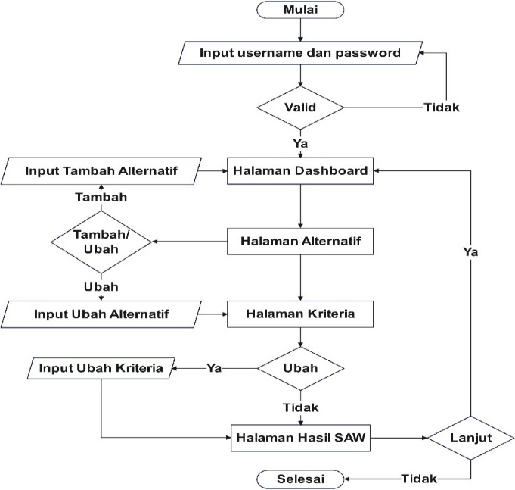

**Figure 1. Application Process Flowchart**

Figure 1 explains the process of a system that begins with the user entering a username and password. Subsequently, the system verifies the validity of this information. If valid, the user is directed to the dashboard page; if not, the user is prompted to re-enter their login information. On the dashboard page, the user has the option to add or update alternatives. If the user chooses to add an alternative, they are directed to the alternatives page, where they can add or modify existing alternatives.

After adding or updating alternatives, the user can modify the existing criteria on the criteria page. The system checks whether the user wishes to update the criteria; if yes, the user can make changes, and if not, the user is directed to the SAW (Simple Additive Weighting) results page. On the SAW results page, the outcomes of the SAW process are displayed. The user can then choose whether to continue or not. If the user opts not to continue, the process ends; if they choose to continue, the process returns to the dashboard page. The process concludes when the user decides not to continue further and exits the system.

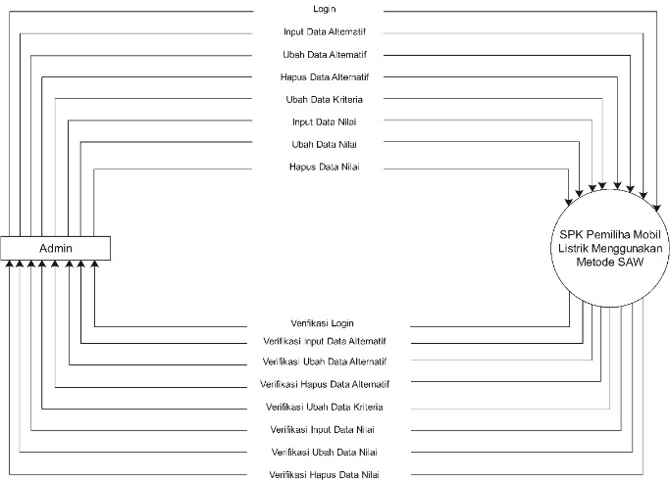

**Figure 2. DFD Level 0**

Figure 2 describes the interaction process between the Admin and the Decision Support System (DSS) for selecting electric cars using the Simple Additive Weighting (SAW) method. The process begins with the Admin logging into the system to ensure authorization. Upon successful login, the Admin can manage data, including adding, updating, or deleting alternative data (electric cars under consideration) and modifying the evaluation criteria. The Admin can also add, update, or delete the scores assigned to each alternative based on the existing criteria. Every action performed by the Admin, such as data input, updates, or deletions, is verified by the DSS to ensure its validity. Once all data is verified, the DSS applies the SAW method to calculate and provide a recommendation for the best electric car based on the predefined criteria. Thus, this process ensures that the decisions generated by the system are based on valid and verified data.

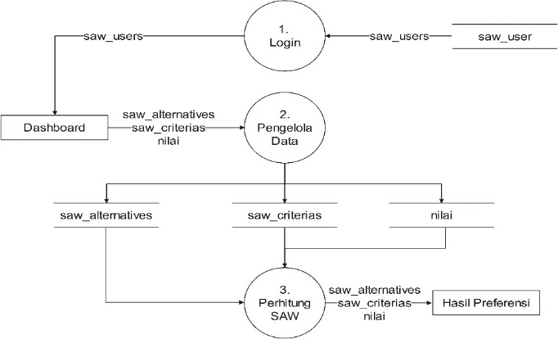

**Figure 3. DFD Level 1**

Figure 3 outlines the three main processes in the electric car selection system using the SAW (Simple Additive Weighting) method. The first process is login, where the user (admin) authenticates to access the system, with user data being verified before they are directed to the dashboard. After logging in, the user can manage alternative electric car data, evaluation criteria, and the scores assigned based on those criteria. This data management process includes adding, updating, and deleting data necessary for analysis. The managed data is then used in the SAW calculation process, where the system computes preference values for each alternative electric car. The result of this calculation is a recommendation for the best electric car based on the previously entered and processed data. This diagram illustrates the data flow from the login process to decision-making, ensuring each step is carried out in a structured and systematic manner.

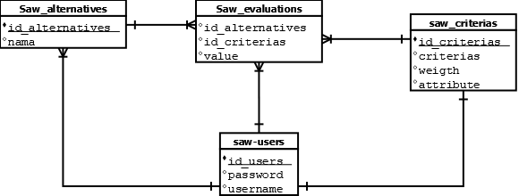

**Figure 4. ERD**

Figure 4 depicts the relationships between tables in a system that utilizes the SAW (Simple Additive Weighting) method. The "saw_users" table stores user information, including attributes such as id_users, password, and username. This table is linked to the "saw_alternatives" table, which stores alternative data with attributes like id_alternatives and name.

The "saw_criterias" table stores criteria data with attributes such as id_criterias, criterias, weight, and attribute. This table is connected to the "saw_evaluations" table, which links alternatives and criteria through id_alternatives and id_criterias, and stores evaluation scores in the value attribute.

Overall, the process involves users logging in through the "saw_users" table, then managing alternatives in the "saw_alternatives" table and criteria in the "saw_criterias" table. The evaluation between alternatives and criteria is conducted in the "saw_evaluations" table, where each alternative is assessed based on the existing criteria. This diagram illustrates how user data, alternatives, criteria, and evaluations are interconnected within the system to implement the SAW method.

3.3. Implementation

This section discusses the implementation of the system interface based on the design developed in the previous stage.

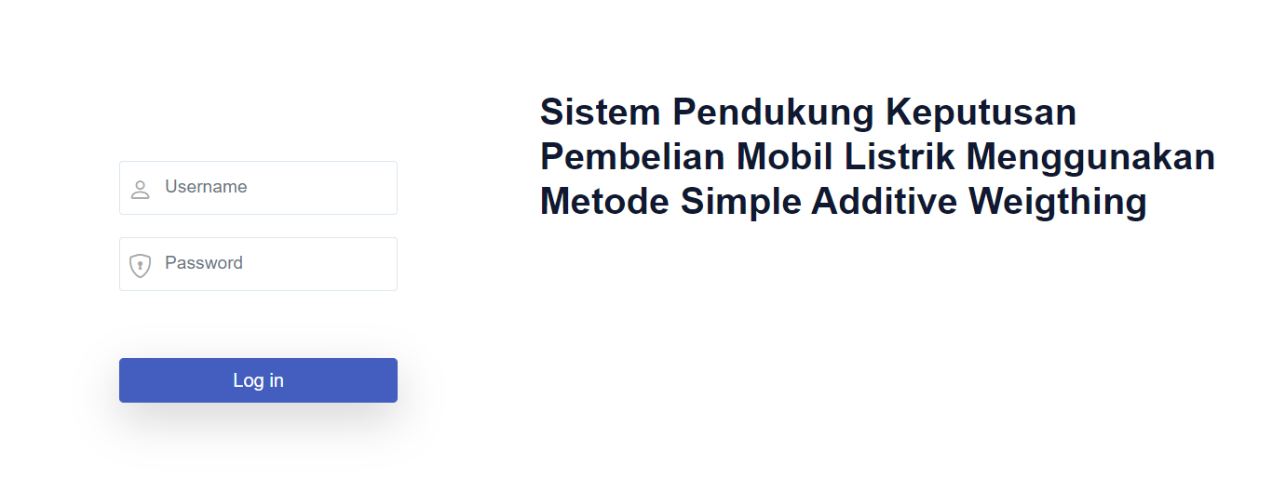

**Figure 5. Login Page**

Figure 5 illustrates the implementation of the login page in the decision support system application for electric car selection using the SAW method. This figure demonstrates where users enter their username and password to access the application.

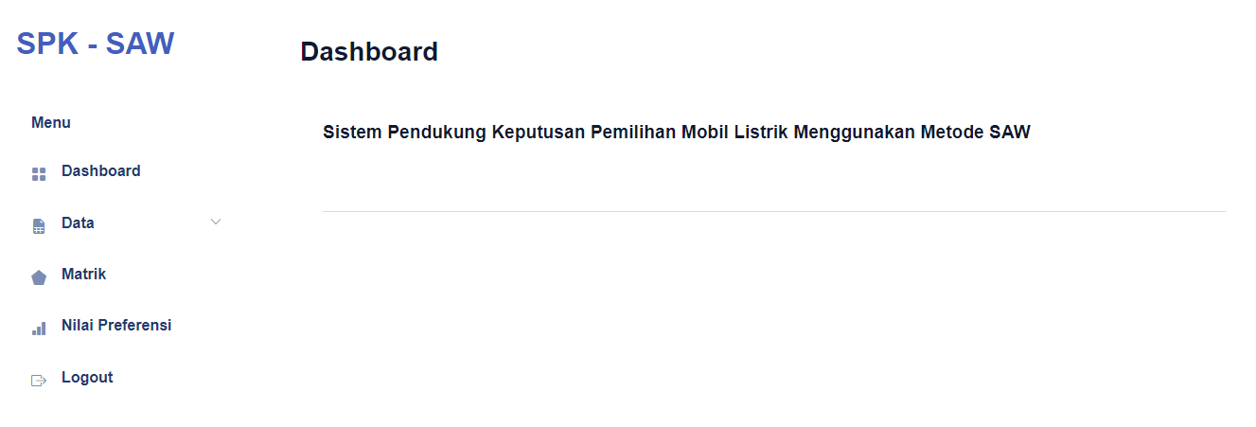

**Figure 6. Dashboard Page**

Figure 6 illustrates the implementation of the dashboard page, where users can access various menus located on the left side, including the dashboard, data, matrix, preference values, and logout.

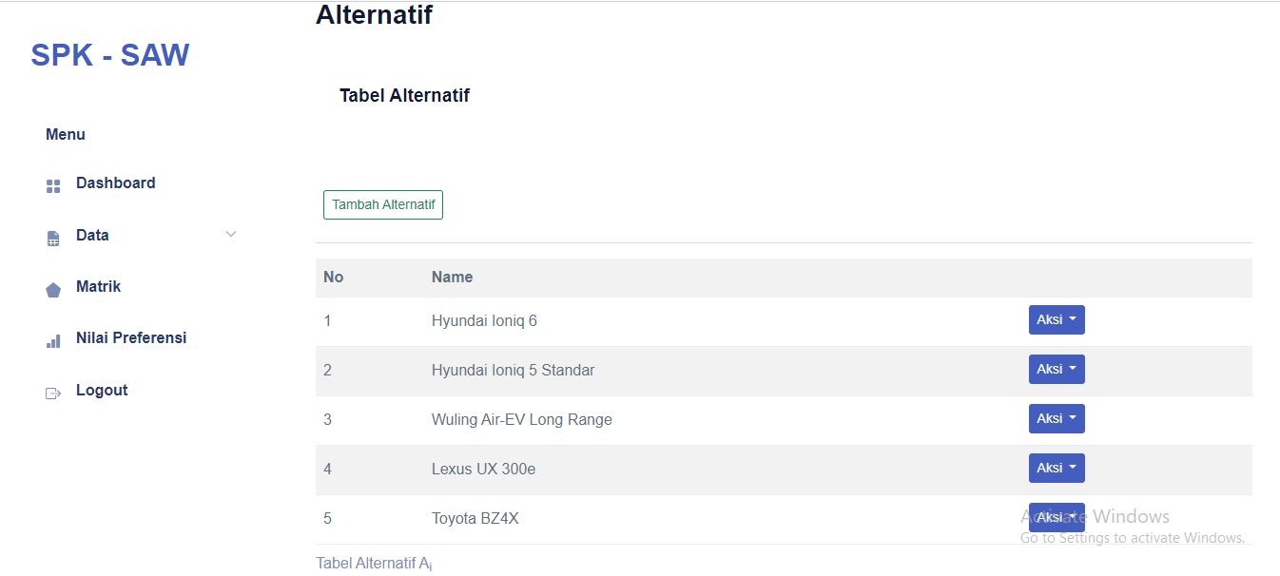

**Figure 7. Alternative Page**

Figure 7 presents the implementation of the alternatives page, where users can view alternative data, input new alternatives, modify existing alternatives, and delete alternatives.

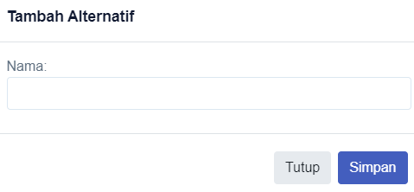

**Figure 8. Add Alternative Page**

Figure 8 depicts the implementation of the add alternative page, where users can enter alternative data.

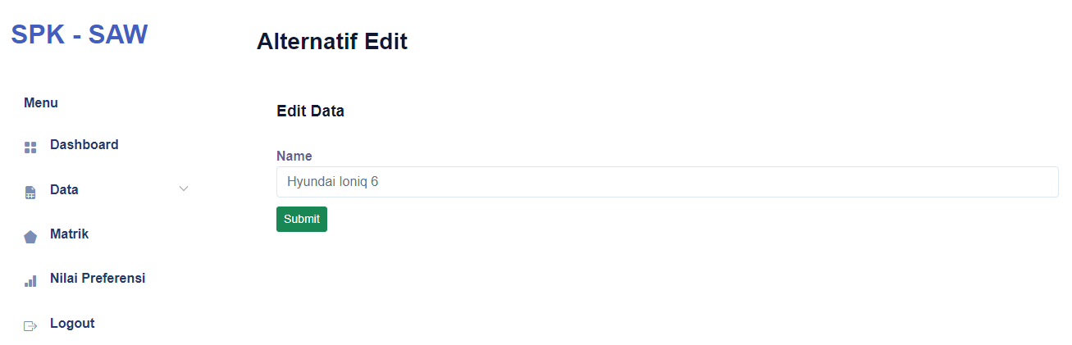

**Figure 9. Edit Alternative Page**

Figure 9 shows the implementation of the edit alternative page, where users can modify alternative data.

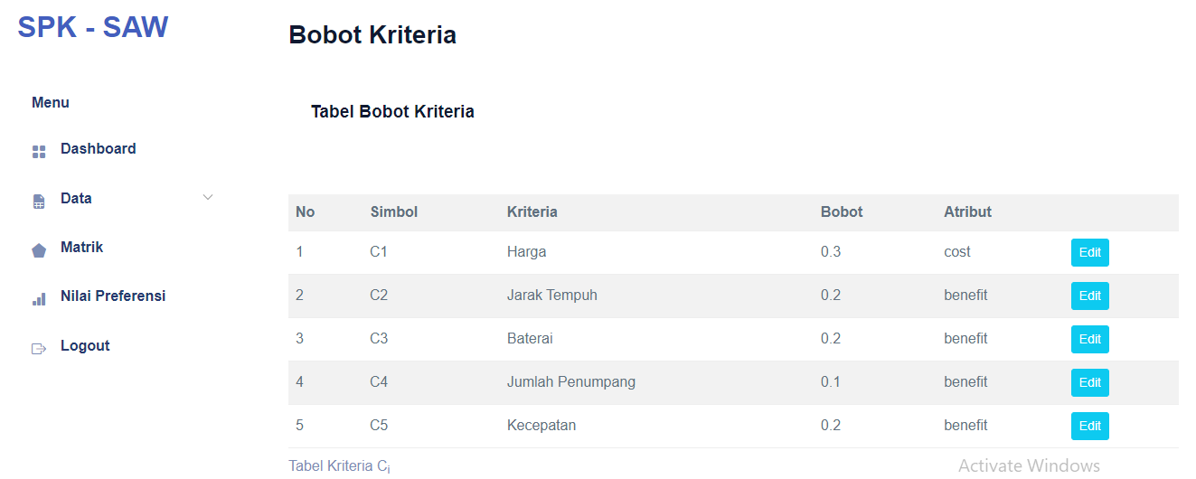

**Figure 10. Criterion Page**

Figure 10 illustrates the implementation of the criteria page, where users can view and modify criteria data, weights, and attributes.

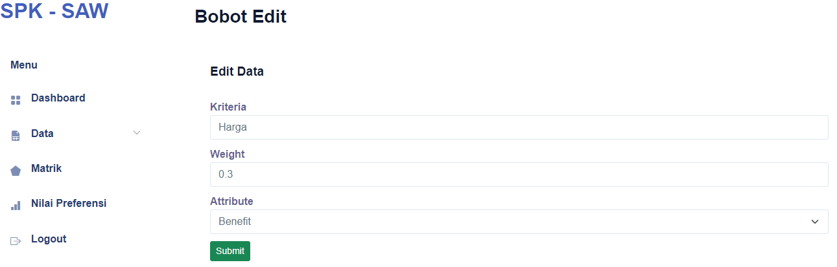

**Figure 11. Edit Criterion Weight Page**

Figure 11 presents the implementation of the edit criteria page, allowing users to modify criteria details, including name, weight, and attributes.

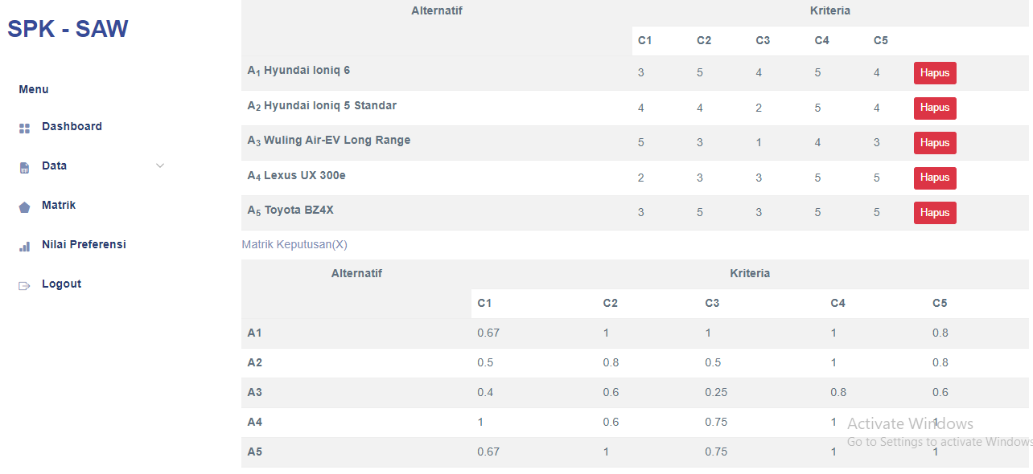

**Figure 12. Matrix Page**

Figure 12 depicts the implementation of the matrix page, where users can view, add, modify, and delete matrix data.

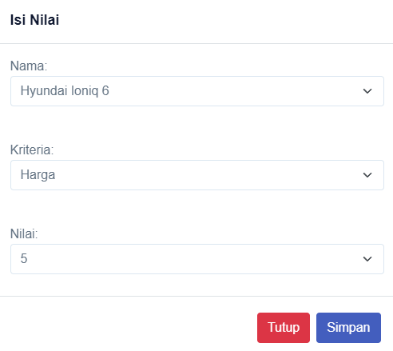

**Figure 13. Add Matrix Page**

Figure 13 shows the implementation of the add matrix page, where users can add and modify matrix data.

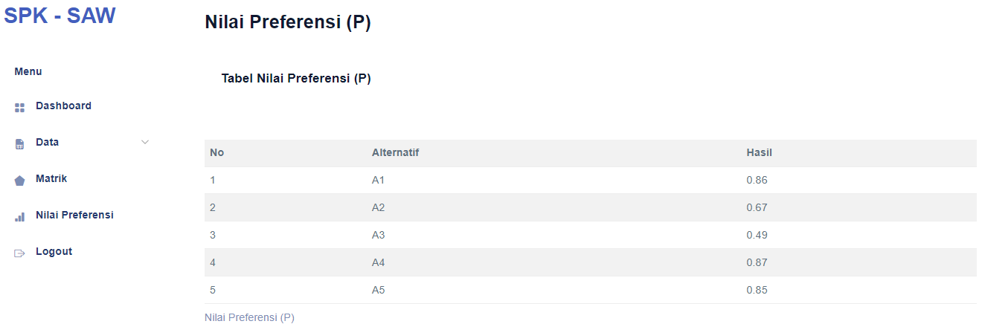

**Figure 14. Preferred Value Page**

Figure 14 illustrates the implementation of the preference page, where users can view the final results of the SAW calculation.

1. **CONCLUSION**

The conclusions obtained are:

1. The decision support system application for selecting electric cars using the SAW method has been successfully implemented, achieving the primary research objective of developing a reliable and user-friendly tool to facilitate electric vehicle (EV) selection based on predefined criteria.
2. The calculation results in the application match the manual calculation results, validating the effectiveness of the SAW method in the context of EV selection, which aligns with the secondary objective of confirming the method’s applicability in this study.
3. The features of the application, including data input, criteria management, and result generation, function as intended, demonstrating the system’s practical utility and contributing to an efficient decision-making process for users.
4. The highest final calculation result is A1 with the Hyundai Ioniq 6, scoring 0.9, while the lowest is A3 with the Wuling Air EV Long Range, scoring 0.54, providing a clear recommendation for the best EV option in the Indonesian market and contributing to informed consumer choices by offering a data-driven ranking of alternatives.

**ACKNOWLEDGEMENTS**

The authors would like to express their sincere gratitude to Universitas Katolik De La Salle Manado for the support and facilities provided throughout this research. Special thanks are also extended to the faculty members and colleagues who contributed valuable insights and feedback during the development of this study.

Furthermore, the authors acknowledge the role of previous research in shaping the methodology and framework of this study. Lastly, we are deeply grateful to our families and friends for their continuous encouragement and motivation.

**REFERENCES**

|  |  |
| --- | --- |
| [1] | R. Rahadiansyah, ”Segini Jumlah Kendaraan Listrik di Indonesia,” detikoto, 02 Mei 2024. [Online]. Available: https://oto.detik.com/mobil-listrik/d-7320993/segini-jumlah-kendaraan-listrik-di-indonesia.. [Använd 19 Juni 2024]. |
| [2] | Frieyadie, ”Penerapan Metode Simple Additive Weight (Saw) Dalam Sistem Pendukung Keputusan Promosi Kenaikan Jabatan,” *Jurnal Pilar Nusa Mandiri,* vol. 12, nr 1, pp. 37-45, 2016. |
| [3] | I. H. Sipahelut och A. F. Rozi, ”Sistem Pendukung Keputusan Pemilihan Rental Mobil Dengan Metode Simple Additive Weighting (SAW),” *Jurnal Teknologi Informasi,* vol. 14, pp. 65-72, 2019. |
| [4] | P. Hendriyati och A. Y. P. Mutiara, ”Sistem Pendukung Keputusan Dalam Pemilihan Mobil Toyota Menggunakan Metode Simple Additive Weigthing Pada Tunas Toyota Cilegon,” *Jurnal Insan Unggul,* vol. 8, nr 1, pp. 40-62, 2020. |
| [5] | E. I. H. U. Anindanitya Prakasita Darma Cahyaning Pratiwi, ”Rancang Bangun Sistem Rekomendasi Pemilihan Mobil SUV Menggunakan Metode Simple Additive Weighting (SAW),” 2020. |
| [6] | M. Ridwan, A. Setiadi, N. Yunita och S. Marlina, ”Penerapan Metode Simple Additive Weighting (SAW) Dalam Penentuan Jenis Mobil Honda Yang Paling Diminati,” *Paradigma,* vol. 21, nr 2, pp. 193-196, 2019. |
| [7] | A. Fadila, ”Sistem Pendukung Keputusan Pemilihan Mobil Baru Merk Toyota Mengunakan Metode Simple Additive Weighting,” vol. 2, nr 8, pp. 1-11, 2022. |
| [8] | R. L. Allo och P. W. Wirawan, ”Implementasi Sistem Pendukung Keputusan Pengadaan Mobil Menggunakan Metode Simple Additive Weighting Pada Aplikasi Rental Mobil,” *Jurnal Masyarakat Informatika,* vol. 11, nr 2, pp. 45-50, 2020. |
| [9] | R. Arundaa och A. A. Pekuwali, ”Penentuan Kelayakan Pemberian Kredit Menggunakan Metode SAW Pada PT. Leasing Arthaprima Finance Kotamobagu,” *Journal of Data Science and Information System (DIMIS),* vol. 2, nr 1, pp. 40-49, 2024. |
| [10] | Frieyadie, I. Nainggolan och D. Asrani, ”Sistem Pendukung Keputusan Penentuan Mekanik Terbaik Menerapkan Metode Simple Additive Weighting (SAW),” *ADA Journal of Information System Research,* vol. 1, nr 2, pp. 45-52, 2024. |
| [11] | T. J. Sapitri, A. K. Hidayah, Y. Reswan och U. Juhardi, ”istem Pendukung Keputusan Pembelian Sepeda Motor Bekas Menggunakan Algoritma Simple Additive Weighting (Saw),” *JURNAL KOMITEK,* vol. 3, nr 1, pp. 197-204, 2023. |
| [12] | R. F. Firmansyah och A. Wardana, ”Sistem Rekomendasi Pemilihan Stok Motor Bekas Pada CV. Bandar Sri Rezeki Menggunakan Metode Simple Additive Weighting,” *Journal of Computers and Digital Business,* vol. 3, nr 2, pp. 69-75, 2023. |
| [13] | R. Mulyadi, K. D. Artika och M. Khalil, ”Perancangan Sistem Kelistrikan Perangkat Elektronik Pada Mobil Listrik,” *Elemen : Jurnal Teknik Mesin,* vol. 6, nr 1, pp. 07-12, 2019. |
| [14] | S. Presiden, ”Peraturan Presiden Republik Indonesia Nomor 79 Tahun 2023 Tentang Perubahan Atas Peraturan Presiden Nomor 55 Tahun 2019 Tentang Percepatan Program Kendaraan Bermotor Listrik Berbasis Baterai (Battery Electric Vehicle) Untuk Transportasi Jalan,” Jakarta, 2023. |
| [15] | D. Bourque, *Information Systems for Business and Beyond*, Washington, DC, USA: Saylor Academy, 2020. [Online]. Available: https://saylordotorg.github.io/text_information-systems-for-business-and-beyond/ |
| [16] | D. O. Wibowo och A. T. Priandika, ”Sistem Pendukung Keputusan Pemilihan Gedung Pernikahan Pada Wilayah Bandar Lampung Menggunakan Metode Topsis,” *Jurnal Informatika dan Rekayasa Perangkat Lunak (JATIKA),* vol. 2, nr 1, pp. 73-85, 2021. |
| [17] | J. D. Manik, A. R. Samosir och Mesran, ”Penerapan Metode Simple Additive Weighting dalam Penerimaan Siswa Magang Pada Universitas Budi Darma,” *sudo Jurnal Teknik Informatika,* vol. 1, nr 2, pp. 51-59, 2022. |